Design of a User-centered Classifier for evaluating Voice Condition
based on the S-choker

Seonghee Min, Yoosoo Oh

School of Computer & communication Engineering, Daegu University
201, Daegudae-ro, Gyeongsan-si, Gyeongsangbuk-do, Republic of Korea
{smin, yoosoo.oh}@daegu.ac.kr

Abstract

The S-choker is a system that can help vocal management by deciding the vocal condition in real time for professional voice users. To evaluate the vocal state based on the S-choker, we should know whether the voice is used or not. Therefore we propose the user-centered classifier that values the voice usage based on the S-choker for professional voice users. The proposed classifier enables real-time learning by utilizing the S-choker data from users. To develop the classifier, we collect sensor data from the S-choker and then apply naive Bayes classification algorism with the received data. The S-choker app can determine whether a user is speaking or not with learning results.

Vocal-management; S-choker; Machine-learning; User-centered; Professional-voice-users

I. Introduction

Professional voice users need a vocal management system because they are exposed to the vocal cord diseases, such as colds, sore throat, vocal cord nodules[1]. The S-choker[2] is a system that can promote vocal status by deciding the vocal condition in real time for professional voice users. The S-choker consists of a choker-type device and a mobile app. It can evaluate the vocal state of the user based on biological signals by measuring heart sensor, GSR sensor, EMG sensor and microphone sensor.
To evaluate the vocal condition, we should know whether the voice is used or not based on the S-choker. However, there is no research to find out whether the sound is used or not by using biosensors. It is necessary to develop a user-centered classifier for voice usage because biological sensory data is different according to each user. Also, we need to build a server that can efficiently manage big data from physiological sensors of the S-choker. Mainly it is essential that we develop a user-centered classifier for vocal usage. The user-centered classifier should learn and manage sensor data according to different characteristics of each user.
Therefore we propose the user-centered classifier that evaluates voice usage based on the S-choker for professional voice users. The proposed classifier enables real-time learning by utilizing the S-choker data from users. The designed S-choker sends measured sensor values to the S-choker app. The S-choker app generates the HBT ontology[3] by integrating sensor values and user’s profile. Then the HBT ontology transfers to the designed HBT server. The HBT server decides to determine voice usage and vocal condition of each user based on learning algorism.
To develop the classifier, we collect sensory data from the S-choker and then apply naive Bayes classification algorism[4] with the received data. The S-choker app can determine whether a user is speaking or not with learning results. Also, it shows voice usage condition, and then a user can monitor the status with a result graph.

II. The Proposed Classifier

Fig. 1 describes a diagram of the proposed classifier. The S-choker measures sensor values around user’s neck. The measured data is sent to the S-choker app through Bluetooth. The S-choker app parses sensory data and integrates user’s profile to generate the HBT ontology. The made data transfers to the HBT server by HTTP communication. The HBT server saves the data in the database of the S-choker. The learning algorism module performs learning by using sensor values and then recognizes the voice usage condition. The recognition result is transferred to the Alarm Message Print Module in the S-choker app. The S-choker app can help to manage the vocal state of a user by using alarm messages.

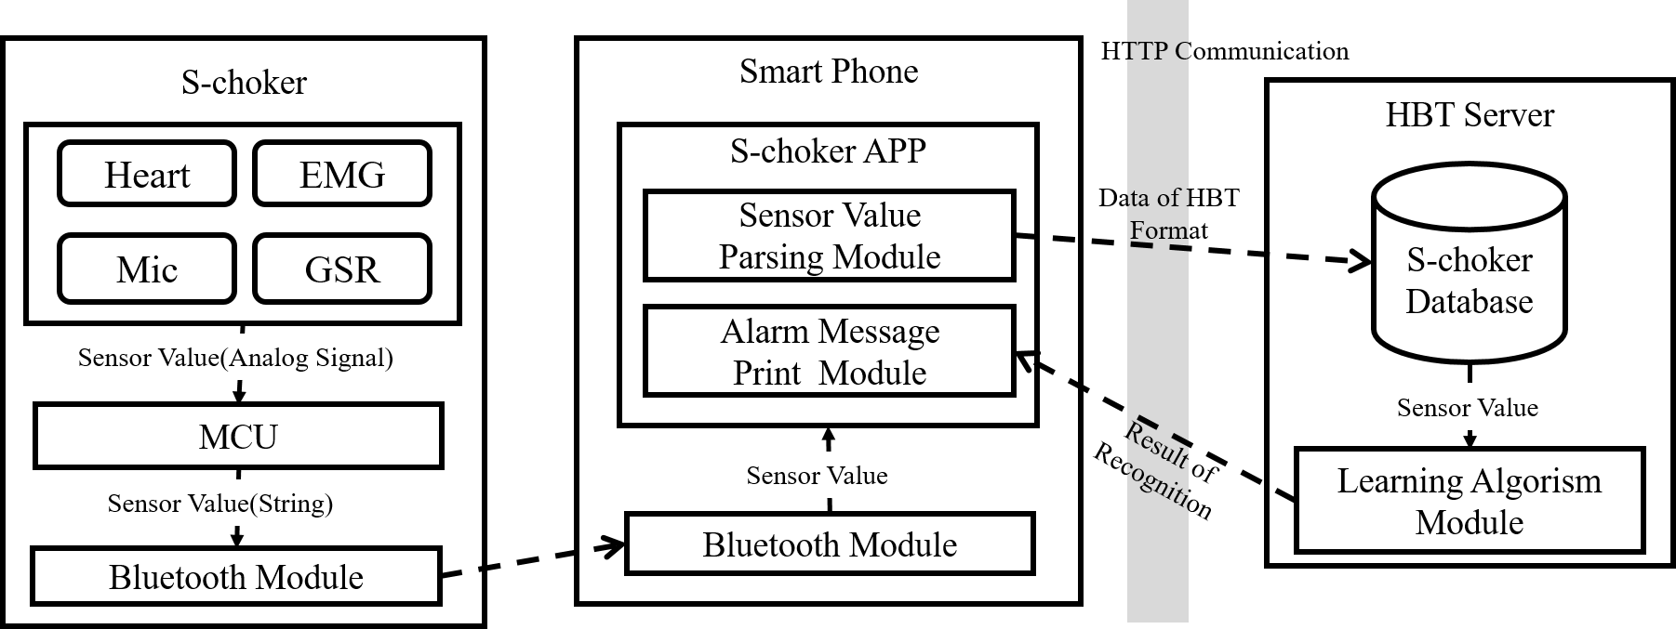

Fig. 1 A diagram of the proposed classifier.

Fig. 2 describes the HBT ontology generated in the S-choker app. The user’s profile information saved in the Head ontology. The user’s profile information has a user ID, gender, age, and Job. The gender and age of a user have a difference in acoustic phonetics at the fundamental frequency[4]. Especially professional voice users are more likely to experience vocal diseases than non-professional voice users[5]. So, we should save this user’s profile information. The sensor values are kept in the Body ontology. Also, the recognition results and the accuracy are saved in the Tail ontology.

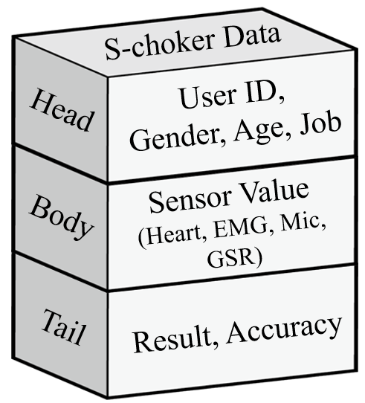

Fig. 2 The HBT ontology generated in the S-choker app.

We develop a prototype of the proposed classifier. The developed classifier performs learning based on collected sensory data from the S-choker. We collect the S-choker data when a user speaks, or dose does not speak in a different situation. Used situations are a quiet environment(35.3dB), a normal environment(61.3dB), and a noisy environment(85.6dB). We make 55 training data set and 10 test data set by sampling the collected data from different situations. We apply the gaussian naive Bayes learning algorism. Equation 1 is used for a learning of the developed classifier. represents each sensor value that is measured by heart sensor, GSR sensor, EMG sensor and microphone sensor. has label 0 and 1. The label 0 means that a user does not speak and the label 1 means the opposite.

(1)

We evaluated the developed classifier with a test data set after learning with a training data set. In a quiet environment, the learning accuracy was 100%. However, in a typical situation, the learning accuracy was 80%, and in a noisy environment, it was decreased to 70%. Therefore, we find that the S-choker system needs a filter that calibrates background noises in the noisy environment. Also, we know that it requires a calibration process to compensate errors in biological sensor values.
The classifier can recognize voice usage of the user in real time by applying the S-choker app. Fig. 3 describes a screenshot of the S-choker app. If the S-choker app recognized when a user said, it displays a red pictogram. If the user does not speak, it presents a black pictogram. Moreover, the S-choker app shows graphs about sensory data of the S-choker.

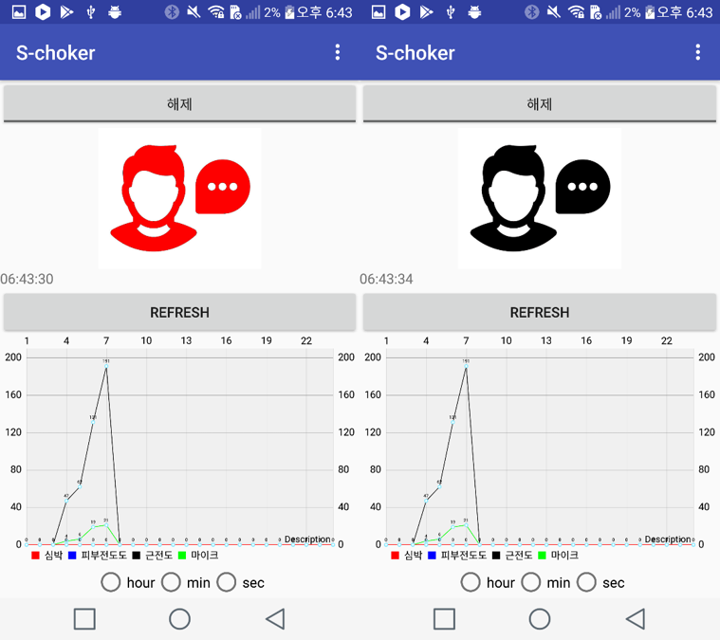

Fig. 3 A screenshot of the S-choker app

III. Conclusion

In this paper, we proposed the user-centered classifier that evaluates the voice usage based on the S-choker for professional voice users. The proposed classifier builds the HBT ontology and estimates the voice usage in real time. Also, it can help to manage the vocal condition of the user by sending evaluation results to the S-choker app. The proposed classifier performs learning the S-choker data. By using the proposed classifier, we collected the S-choker data from each user in various environments. We applied this classifier to the S-choker app; then a user can monitor vocal condition by oneself. In the future, we will implement a learning system that can process the HBT ontology in real time to improve a learning accuracy.

Acknowledgment

This research was supported by Basic Science Research Program through the National Research Foundation of Korea(NRF) funded by the Ministry of Education (NRF-2017R1D1A1B03031454)

References
- J.M. Wingate, W.S. Brown, R. Shrivastav, P. Davenport, “Treatment outcomes for professional voice users,” Journal of Voice, vol. 21, pp. 433-449, July 2007.
- S. Min, Y. Oh, “S-choker: Choker system for user’s vocal condition,” Proceedings of the International Industrial Information Systems Conference 2017, pp. 1-4, June 2017.
- Y. Lee, Y. Oh, “A Study on Obstacle Evaluation Using Wearable Device,” ISIITA 2017, pp. 88-90, January 2017.
- M. Brockmann, M.J. Drinnan, C. Storck, P.N. Carding, “Reliable jitter and shimmer measurements in voice clinics: the relevance of vowel, gender, vocal intensity, and fundamental frequency effects in a typical clinical task,” Journal of voice, vol. 25, pp. 44-53, January 2011.
- J.A. Mattiske, J.M. Oates, K. M. Greenwood, “Vocal problems among teachers: a review of prevalence, causes, prevention, and treatment,” Journal of voice, vol. 12, pp. 489-499, December 1998.

